

IBM Developer

SKILLS NETWORK



Prediction and Decision Making

IBM Developer

SKILLS NETWORK



Decision Making:

Determining a Good Model Fit

To determine final best fit, we look at a combination of:

• Do the predicted values make sense

• Visualization

• Numerical measures for evaluation

• Comparing Models

IBM Developer

SKILLS NETWORK



Do the predicted values make sense

• First we train the model

lm.fit (df ['highway-mpg' ], df ['prices' ])

• Let's predict the price of a car with 30 highway-mpg.

lm.predict (np.array(30.0).reshape(-1,1) )

• Result: $ 13771.30

lm.coef_

-821.73337832

• Price = 38423.31 821.73* highway-mpg

IBM Developer

SKILLS NETWORK



Do the predicted values make sense

IBM Developer

SKILLS NETWORK



Do the predicted values make sense

• First we import numpy

import numpy as np

• We use the numpy function arrange to generate a sequence from 1

to 100

new_input=np.arange(1,101,1).reshape(-1,1)

1

2

…

99

100

IBM Developer

SKILLS NETWORK



Do the predicted values make sense

• We can predict new values

yhat=lm.predict (new_input)

IBM Developer

SKILLS NETWORK



Visualization

• Simply visualizing your data with a regression

IBM Developer

SKILLS NETWORK



Residual Plot

IBM Developer

SKILLS NETWORK



Visualization

IBM Developer

SKILLS NETWORK



Numerical measures for Evaluation

IBM Developer

SKILLS NETWORK

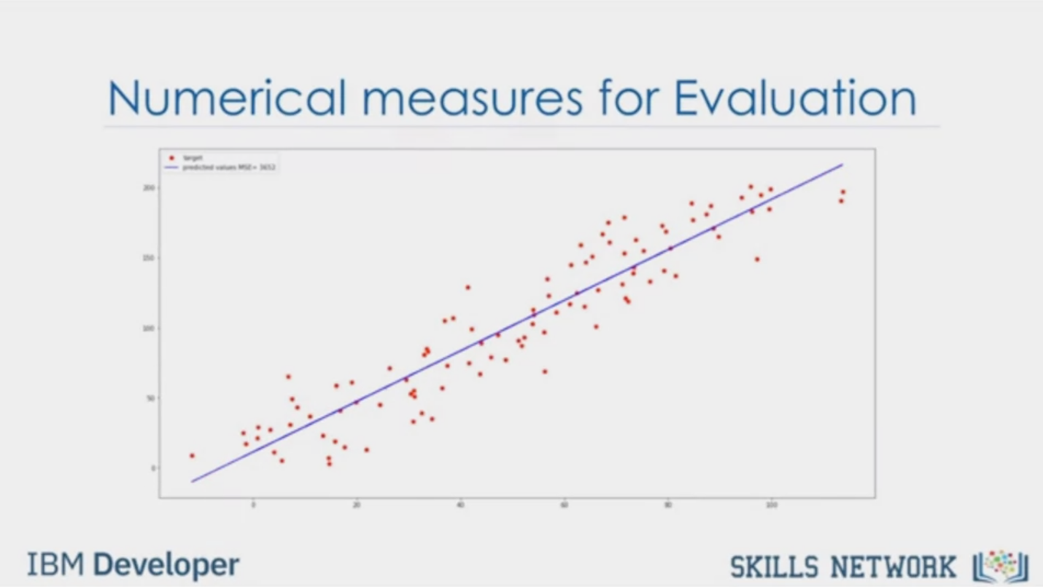

Numerical measures for Evaluation

IBM Developer

SKILLS NETWORK

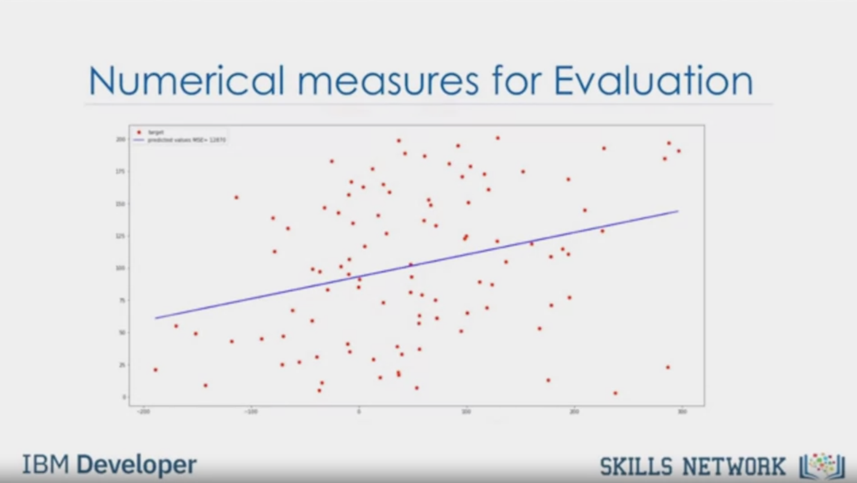

Numerical measures for Evaluation

IBM Developer

SKILLS NETWORK

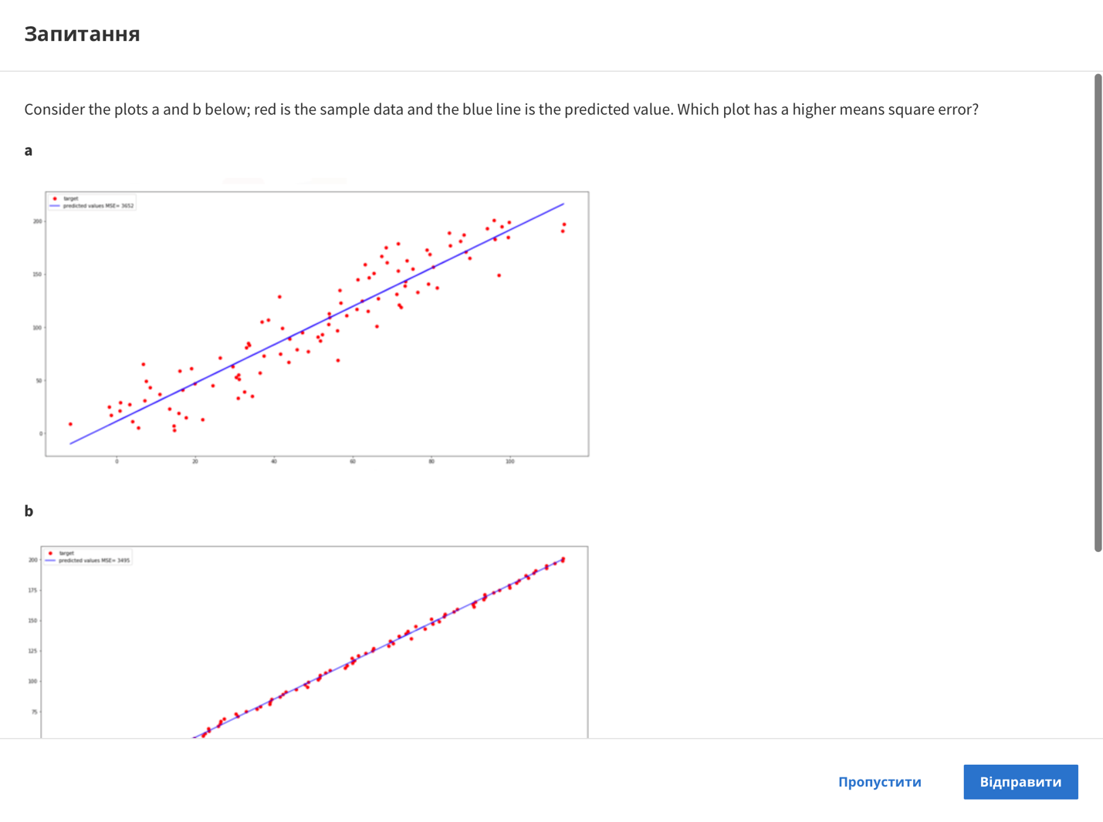

Question

Consider the plots a and b below; red is the sample data and the blue line is the predicted value. Which plot has a higher means square error?

a

b

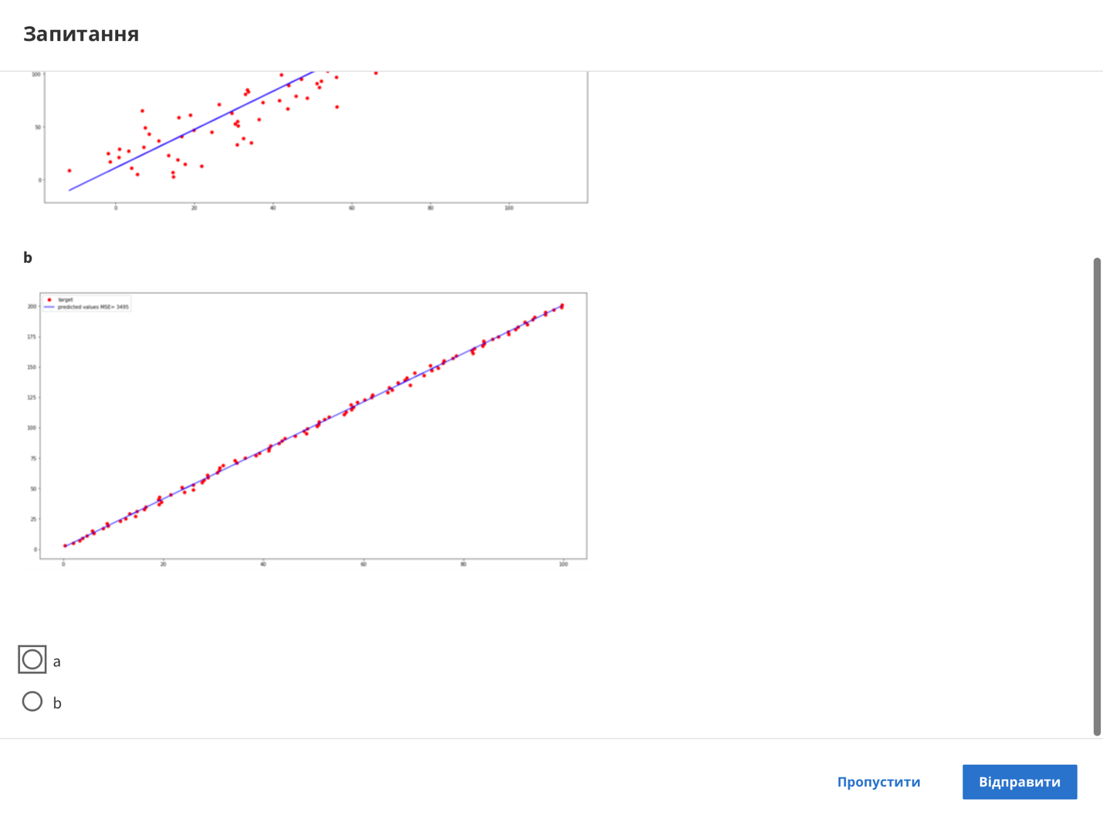

a

b

Skip

Send



Numerical measures for Evaluation

IBM Developer

SKILLS NETWORK

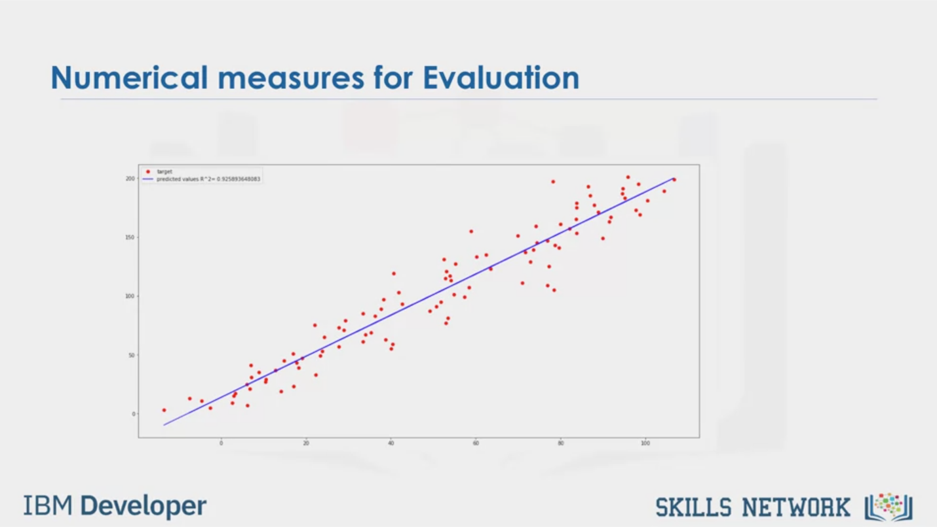

Numerical measures for Evaluation

IBM Developer

SKILLS NETWORK

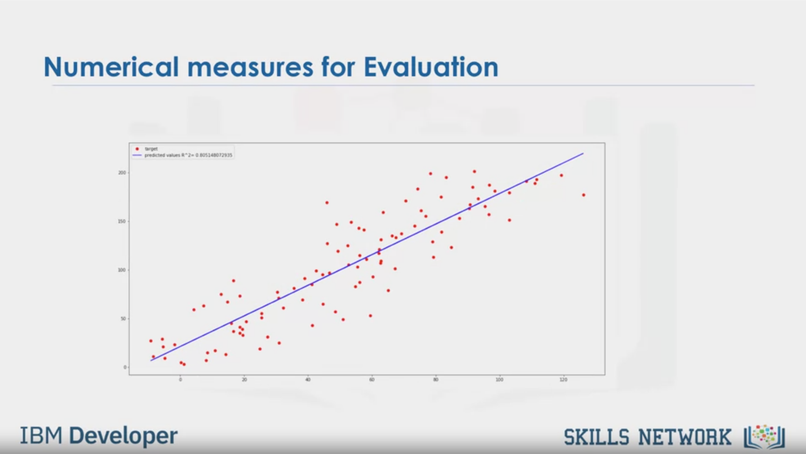

Numerical measures for Evaluation

IBM Developer

SKILLS NETWORK

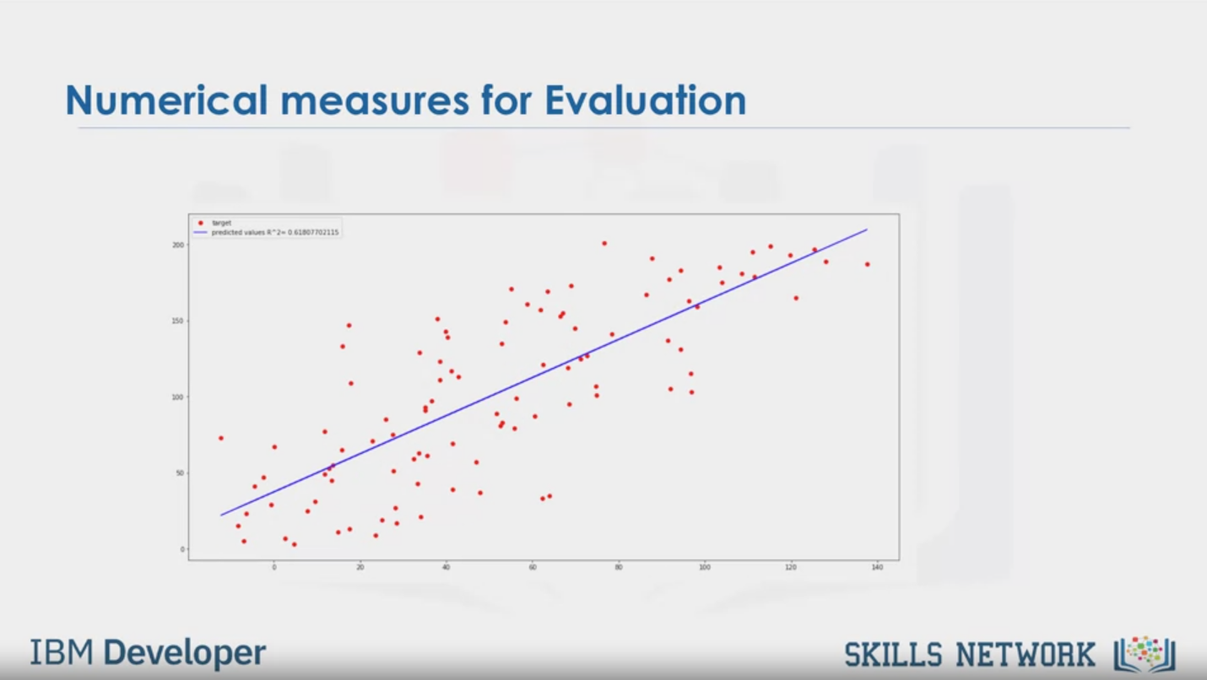

Numerical measures for Evaluation

IBM Developer

SKILLS NETWORK

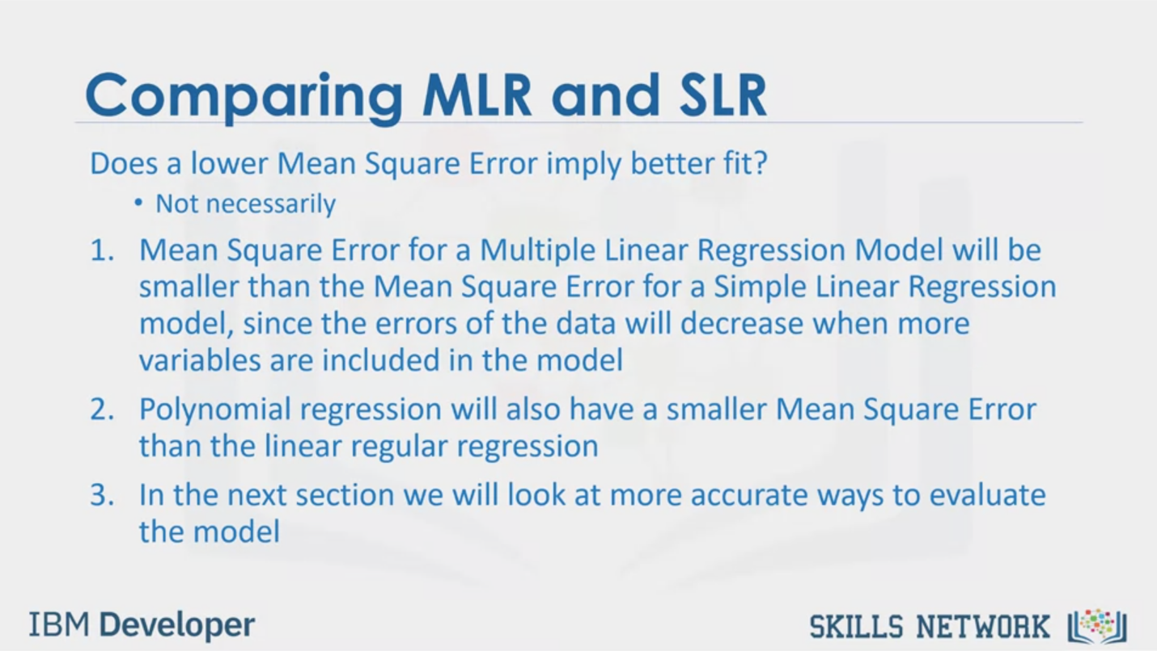

Comparing MLR and SLR

Does a lower Mean Square Error imply better fit?

• Not necessarily

1. Mean Square Error for a Multiple Linear Regression Model will be

smaller than the Mean Square Error for a Simple Linear Regression

model, since the errors of the data will decrease when more

variables are included in the model

2. Polynomial regression will also have a smaller Mean Square Error

than the linear regular regression

3. In the next section we will look at more accurate ways to evaluate

the model

IBM Developer

SKILLS NETWORK



IBM Developer

SKILLS NETWORK

In this video our final topic will be on prediction and decision making.

How can we determine if our model is correct?

The first thing you should do is make sure your model results make sense. You should always use

visualization, numerical measures for evaluation, and comparing between different models.

Let's look at an example of prediction. If you recall we trained the model using the fit

method. Now, we want to find out what the price would be for a car that has a highway miles per

gallon of 30. Plugging this value into the predict method gives us a resulting price of

$13,771.30 this seems to make sense. For example, the value is not negative, extremely high, or

extremely low. We can look at the coefficients by examining the coeff underscore attribute. If you

recall the expression for the simple linear model that predicts price from highway miles per gallon.

This value corresponds to the multiple of the highway miles per gallon feature.

As such an increase of one unit in highway miles per gallon

the value of the car decreases approximately 821 dollars. This value also seems reasonable

sometimes your model will produce values that don't make sense.

For example, if we plot the model out for highway miles per gallon in the ranges of 0 to 100 we

get negative values for the price. This could be because the values in that range are not realistic

the linear assumption is incorrect or we don't have data for cars in that range. In this case

it is unlikely that a car will have fuel mileage in that range so our model seems valid. To

generate a sequence of values in a specified range import numpy then use the numpy arrange function

to generate the sequence the sequence starts at 1 and increments by 1 until we reach 100.

The first parameter is the starting point of the sequence. The second parameter is the endpoint

plus one of the sequence the final parameter is the step size between elements in the sequence.

In this case it's one so we increment the sequence one step at a time from one to two and so on.

We can use the output to predict new values the output is a numpy array many of the values are

negative. Using a regression plot to visualize your data is the first method you should try.

See the labs for examples of how to plot polynomial regression

for this example the effect of the independent variable is evident in this case. The data

trends down as the dependent variable increases the plot also shows some non-linear behavior.

Examining the residual plot we see in this case, the residuals have a curvature suggesting

non-linear behavior. A distribution plot is a good method for multiple linear regression.

For example, we see the predicted values for prices in the range from thirty thousand to fifty

thousand are inaccurate this suggests a non-linear model may be more suitable or we need more data in

this range. The mean square error is perhaps the most intuitive numerical measure for determining

if a model is good or not. Let's see how different measures of mean square error impact the model.

The figure shows an example of a mean square error of 3495. This example has a mean square

error of three thousand six hundred and fifty two. The final plot has a mean square error of twelve

thousand eight hundred and seventy. As the square error increases the targets get further from the

predicted points. As we discussed r squared is another popular method to evaluate your model.

It tells you how well your line fits into the model. r squared values range from zero to one.

r squared tells us what percent of the variability in the dependent variable is accounted for by

the regression on the independent variable. An r squared of 1 means that all movements of another

dependent variable are completely explained by movements in the independent variables.

In this plot we see the target points in red and the predicted line in blue.

An r squared of 0.9986 the model appears to be a good fit. That means that more than 99

of the variability of the predicted variable is explained by the independent variables. This model

has an r squared of 0.9226 there still is a strong linear relationship model is still a good fit.

An r squared of 0806 of the data we can visually see that the values are scattered around the line.

They are still close to the line and we can say that 80 percent of the variability of the

predicted variable is explained by the independent variables. And an r squared 0.61 means that

approximately 61 percent of the observed variation can be explained by the independent variables.

An acceptable value for r squared depends on what field you are studying and what your

use case is. Falcon Miller 1992 suggests that an acceptable r squared value should be at least 0.1.

Does a lower mean square error imply better fit? Not necessarily MSE4 and MLR model will be smaller

than the MSE for an SLR model. Since the errors of the data will decrease when more variables are

included in the model. Polynomial regression will also have a smaller MSE than regular regression

in the next section we will look at more accurate ways to evaluate the model.